GROUP -8
D.Sukriti – 2620030493
T.Sahasra - 2620030108
Y.Geethika – 2620030519

ABSTRACT
Online Store Cart & Order Pipeline~ JAVA Project~
PURPOSE
The Online Store Cart & Order Pipeline is a Java-based project that develops basic process of purchasing products through an online store. The main purpose of the project is to create a simple and organized system in which a user can view available products, select items, add them to a shopping cart, modify quantities, remove items, get feedback and check the total cost before placing an order. The project focuses on representing the flow of an online purchase using core Java programming concepts rather than building a complete commercial application.
The main idea is to track the journey of a product from the moment a customer selects it, through the shopping cart and order placement, until the order is delivered.
  - STRUCTURE
The system begins with a product list containing details such as product name, product ID, price, available quantity, applicable discounts, coupons, deals, payment options, and other additional features. When a customer selects a product, it is added to the cart along with the required quantity. The cart can then be updated when the user changes quantities or removes products. The program calculates the subtotal and final cart value based on the selected items and quantities. Basic validation can also be included to handle situations such as an empty cart, an invalid quantity, or a quantity greater than the available stock.
After the customer confirms the cart, the program creates an order and assigns it an order ID. The order then moves through a predefined pipeline representing the normal order process: “Order Placed, Order Confirmed, Packed, Shipped, and Delivered”. The current status can be displayed to the user so that the progress of the order is easy to understand. Conditions such as cancellation or unsuccessful processing can also be represented by preventing the order from moving to the next stage when the required condition is not satisfied.
  - DEVELOPMENT
The project will use core Java concepts such as classes and objects, methods, variables, conditional statements, loops, and suitable collection or array structures for storing products and cart items. Separate methods can be used for operations such as displaying products, adding items to the cart, updating quantities, removing items, calculating the total, placing an order, and changing the order status. This structure helps keep the program modular and makes each part of the order pipeline easier to understand and test
OUTCOME
The expected outcome of the project is a simple Java application that demonstrates how a real-world online shopping workflow can be converted into a structured program.
CONCLUSION
The project will provide practical experience in combining multiple Java concepts to solve a realistic problem and can later be extended with features such as inventory updates, customer login, order cancellation, and database connectivity.

CODE
import java.util.Scanner;
public class OnlineStore {
public static void main(String[] args) {

Scanner sc = new Scanner(System.in);

String[] products = {"Laptop", "Headphones", "Mouse", "Keyboard"};
double[] prices = {50000, 2000, 800, 1500};

int[] cart = new int[4];

int choice;

do {
System.out.println("\n===== ONLINE STORE CART & ORDER PIPELINE =====");
System.out.println("1. View Products");
System.out.println("2. Add Product to Cart");
System.out.println("3. View Cart");
System.out.println("4. Place Order");
System.out.println("5. Exit");

System.out.print("Enter your choice: ");
choice = sc.nextInt();

switch (choice) {

case 1:
System.out.println("\n--- Products ---");

for (int i = 0; i < products.length; i++) {
System.out.println((i + 1) + ". " + products[i]
+ " - Rs." + prices[i]);
}
break;

case 2:
System.out.println("\n--- Products ---");

for (int i = 0; i < products.length; i++) {
System.out.println((i + 1) + ". " + products[i]
+ " - Rs." + prices[i]);
}

System.out.print("Enter product number: ");
int product = sc.nextInt();

if (product >= 1 && product <= products.length) {
cart[product - 1]++;
System.out.println(products[product - 1]
+ " added to cart!");
} else {
System.out.println("Invalid product number.");
}
break;

case 3:
System.out.println("\n--- Your Cart ---");

double total = 0;

for (int i = 0; i < products.length; i++) {

if (cart[i] > 0) {
double itemTotal = cart[i] * prices[i];

System.out.println(products[i]
+ " x " + cart[i]
+ " = Rs." + itemTotal);

total += itemTotal;
}
}

System.out.println("Total: Rs." + total);
break;

case 4:
double orderTotal = 0;

for (int i = 0; i < products.length; i++) {
orderTotal += cart[i] * prices[i];
}

if (orderTotal == 0) {
System.out.println("Your cart is empty!");
} else {
System.out.println("\n===== ORDER CONFIRMED =====");

for (int i = 0; i < products.length; i++) {
if (cart[i] > 0) {
System.out.println(products[i]
+ " x " + cart[i]);
}
}

System.out.println("Total Amount: Rs." + orderTotal);
System.out.println("Order Status: Confirmed");
System.out.println("Thank you for shopping!");

// Empty the cart after ordering
for (int i = 0; i < cart.length; i++) {
cart[i] = 0;
}
}
break;

case 5:
System.out.println("Thank you! Visit again.");
break;

default:
System.out.println("Invalid choice.");
}

} while (choice != 5);

sc.close();
}
}
OUTPUT
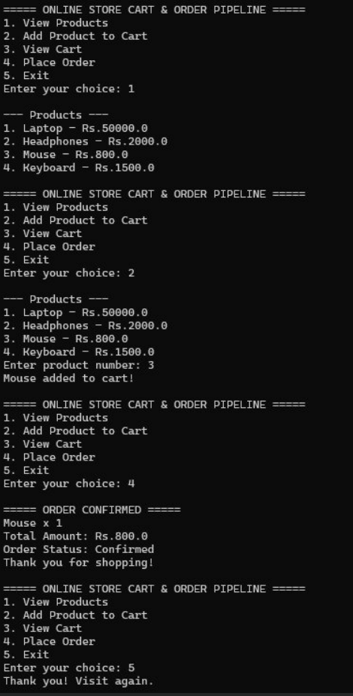& Order Pipeline project aims to create a simple Java-based system for managing products, shopping carts, and orders. It demonstrates how Java concepts can be used to model a real-world online shopping process efficiently and systematically.

